Install and Setup the PayWise WordPress Plugin
Install the PayWise Plugin
Video: https://www.youtube.com/watch?v=_21wVYWBfRQ
1. Download the zipped plugin file
2. Upload the zipped plugin file to WordPress
3. Activate the plugin
Setup the PayWise Plugin
1. Login to your WordPress site as admin
2. Click on Plugins
3. Click on Installed Apps
4. Click on the WooCommerce plugin
5. Click on Settings
6. Click on the Payments tab
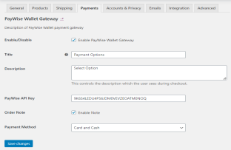
7. Click on PayWise Wallet Gateway
8. Enable the PayWise Wallet Gateway
9. Enter Payment Options as the Title
10. Paste your PayWise API Key into the PayWise API Key field*
11. Enable or Disable Order Note
12. Select Payment Method: Cash, Card or Cash and Card (cash payments made at PayWise agents) 13. Send your website URL to ian.alleyne@paywise.co

*Get Your PayWise API Key
1. Login: (a) Go to www.paywise.co (b) Click on New App
2. Go to Settings/View API Key
3. Copy and paste API Key

